CS 2033
Multimedia and Communications

Lab 01: Refresher on FTP and Introduction to Affinity Photo
- FTP and Image Processing -

REMEMBER TO BRING YOUR MEMORY STICK TO EVERY LAB!

File Transfer Protocol (FTP)

FTP (File Transfer Protocol) enables a user to transfer files between his/her local computer (the computer you are sitting working at) and a remote server. Some terminology:
  - hosting – placing website files on a computer that is set up to allow access to those files from the Internet
  - server – a computer that is set up to host websites. In this course, we will be hosting our files on two servers: Panther and GAUL
  - downloading - copying files from a remote server (such as Panther) to the local PC computer (the computer you are using right now)
  - uploading - copying files from the local PC to the remote server
A common use for an ftp (file transfer protocol) package is to obtain files from archive sites, which are servers used to store files. A wide variety of files are available from these sites - applications, games, utilities, documentation - some of which include audio, video, and/or graphics.

WinSCP and FileZilla are two of the most popular FTP programs. You will need to use FTP for some labs and all the assignments in this course (just like you did in CS 1033).

FTP allows you to move files (such as .jpg files or .html files) between the machine you are sitting at and working on (your local machine) and the web server (such as panther.uwo.ca or gaul.csd.uwo.ca)
Your local machine
panther.uwo.ca
Upload
Download

GETTING STARTED AND CREATING A “Publish Area” ON THE SERVER PANTHER:
It creates a folder that will hold the items you want to put on the World Wide Web.
THIS STEP ONLY NEEDS TO BE DONE ONCE.

- Make sure all your passwords are in sync by open an Internet browser going to the following site: http://idm.uwo.ca and go to the profile tab, click on sync password and click on the sync button.

- If you are in MC230 over the next 10 weeks and you have any problems such as the monitor flickering, the software not working, the internet not working, please report it at this site: http://www.csd.uwo.ca/prob_report.html

- If you are in NCB105b over the next 10 weeks and have any problems such as the monitor flickering, the software not working, the internet not working, please report it to ITS at this site: http://www.uwo.ca/its/about-its/contact.html

- Start the browser → Internet Explorer and go to the following website: https://wts.uwo.ca/services/web/activate_my_personal_web_space.html You should then see this:
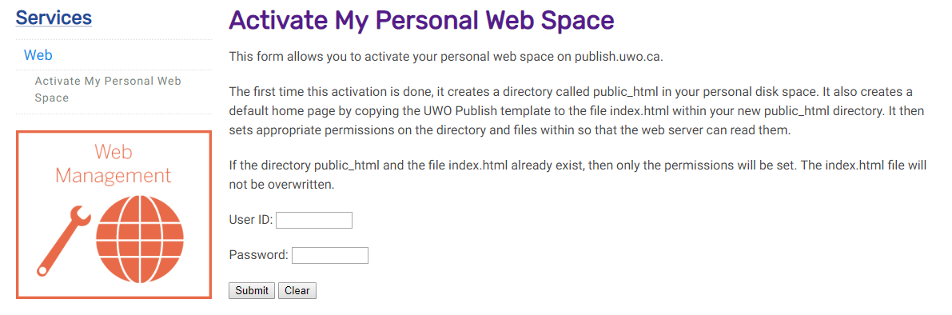
- Enter your UWO username/user id and your UWO password and hit the Submit button. In a few minutes (don't panic if it doesn't show up right away!) a special area (really just a folder) will be created. Anything contained in this folder will now appear on the World Wide Web. Thus you can put files into this folder and then see them using IE or Firefox. The name of this folder will be public_html

UNDERSTANDING HOW TO REFER TO (ACCESS) YOUR MEMORY STICK (IT WILL LIKELY BE CALLED THE F: DRIVE):

NOTE: For the remaining labs in CS2033 remember that folder and directory mean the same thing. Because the set up in MC230 is slightly differ than the set up in NCB105, we have to do a bit of setup so that your memory stick is pointing to the same place in both lab rooms. Normally the memory stick will map to the F: drive, so this lab will ALWAYS refer to the F: drive but just in case, perform the steps below to figure out which drive your memory stick was mapped to. Then we will save everything to the F: drive (i.e. your stick)

- Put your memory stick into the USB slot

- Open up the Explorer Window (right-click on the Windows 10 icon and click “File Explorer”, then scroll down in the left panel until you see “This PC” and click on it.).
- Look and see which drive your memory stick was mapped to (often D: E: or F:) It will likely be under an area labeled “Devices and drives”. Make sure you remember the drive letter and substitute it every time you see F: if your memory stick was mapped to a different drive. It will look like this:
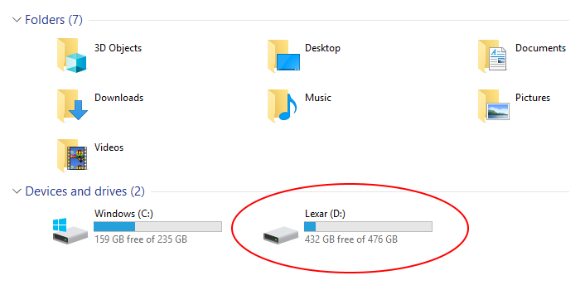
- Double click on the F:\ drive (memory stick) to get into this area.
- Once you have gone into your F:\ drive, create a folder (i.e. directory) called cs2033.
This is where you will organize your labs and assignments for the course.

LOADING THE LAB 1 FILES ONTO YOUR MEMORY STICK:

This is where the instructors provide you with the material needed to complete the labs. For each lab we will place files containing images, documents, video clips, etc that you will need to complete the lab a server. You will need to move them from the server to your F: drive in the cs2033 folder (directory) every week for each lab.

- On your memory stick, create a folder called cs2033
- Move into the cs2033 folder and create a folder calls labs and inside it create another folder called lab01.
NOTE: it is VERY important you name your files and folders carefully and use the exact same spelling and exact same case (usually make every file/folder name lowercase with no spaces in the folder name or file names
- Move to the cs2033/labs/lab01 folder and create a file called images
- Move to the cs2033/labs/lab01/images folder.
- Using Chrome, IE, or Firefox open the following website: http://www.csd.uwo.ca/~bsarlo/cs2033b/labs/lab01/images/

- Right click on the file called middlesexcollege.jpg and select Save target as…(or Save link as…) and save this file to the folder on your USB called cs2033/labs/lab01/images
- Right click on the file called thegradclub.jpg and select Save target as… (or Save link as…) and save this file to the folder on your USB stick called cs2033/labs/lab01/images
- Using IE or Firefox, open the following website: http://www.csd.uwo.ca/~bsarlo/cs2033b/labs/lab01/

- Right click on the file called: picturepage.html and save it to your memory stick to the folder called cs2033/labs/lab01
- Right click on the file called: lab01.doc and save it to your memory stick to the folder called cs2033/labs/lab01
- Right click on the file called: lab01.pdf and save it to your memory stick to the folder called cs2033/labs/lab01
WORKING ON PANTHER:

We are now going to learn how to use WinSCP to work with panther (the remote server that will store your completed webpages). The next few pages will describe the essential parts:
Connecting with WinSCP and Creating a Folder
Since panther is a remote server, you must use a FTP program such as WinSCP or FileZilla (or Fugu for Mac users) to connect and move files onto panther. Above, by doing the “Activate my Personal Web Site, you created a “publish area” – this is where you will put a copy of your completed websites/files/assignment work so that they are viewable on the Internet (in other words, “publishing” your websites).

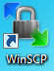
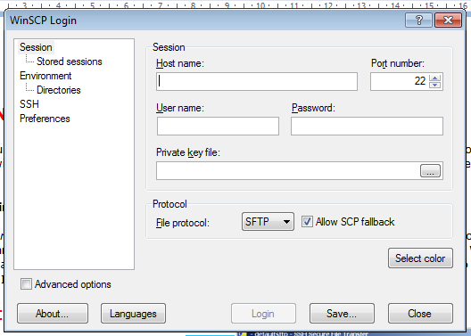
Connecting with WinSCP and Creating a Folder:
- Open WinSCP click on this icon →
and select the Quick Connect button. You will then see the screen to the right.
  - Enter panther.uwo.ca in the Host Name: box
  - Enter your UWO userid in the User name: box
  - Enter your UWO password in the Password: box
  - Make sure the Port Number: is 22
  - Click on the Login button

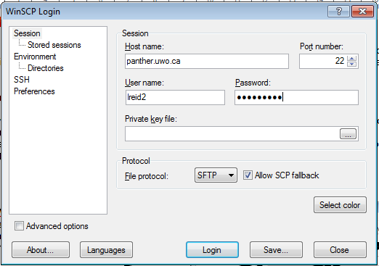
- Your screen should look similar to this:

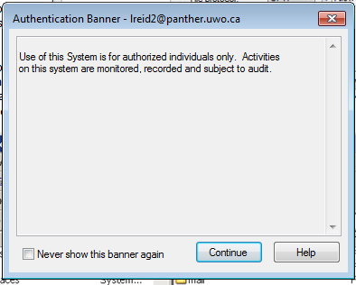
- You may then see this window, just click on Continue

- You will then see something like this window with a folder called public_html on the right side: (Note that your own computer files are on the left side panel. We call this the Local Side. In the right panel is where the panther server files are stored and we call this the Remote side. Some files stored on the remote side can be viewed on the Internet)

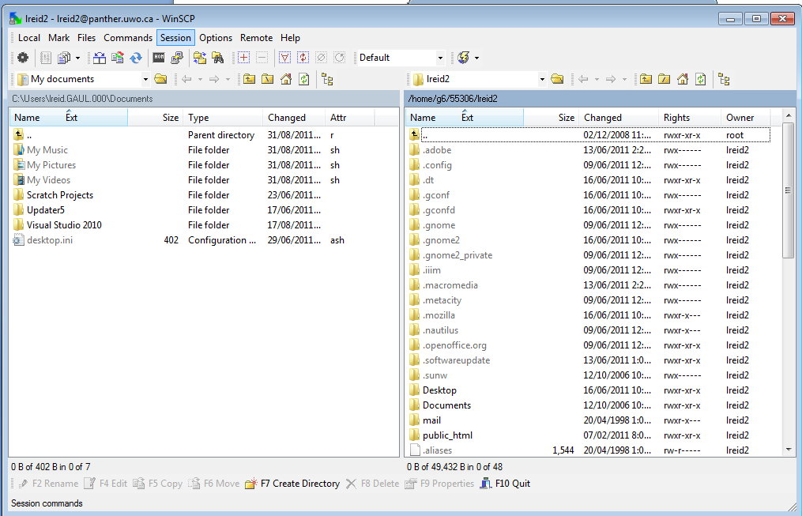

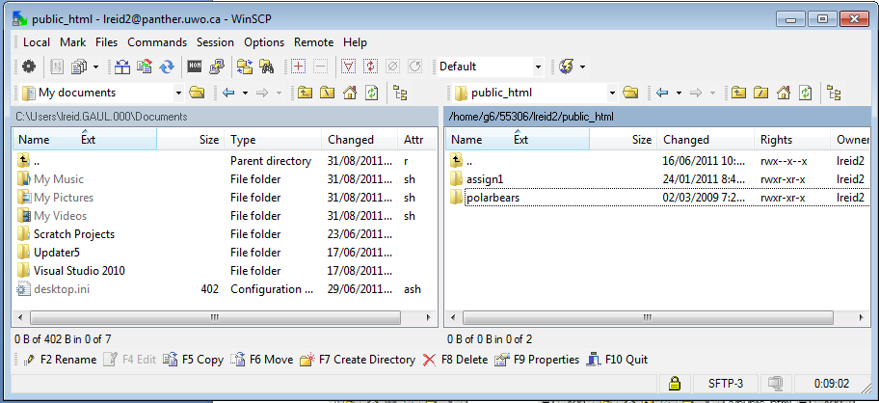
- Once you see your remote files on File Transfer window, double-click the public_html folder (This is your directory called your “publish area”). Note: your public_html folder (directory) might contain other things as well – ignore these for now.

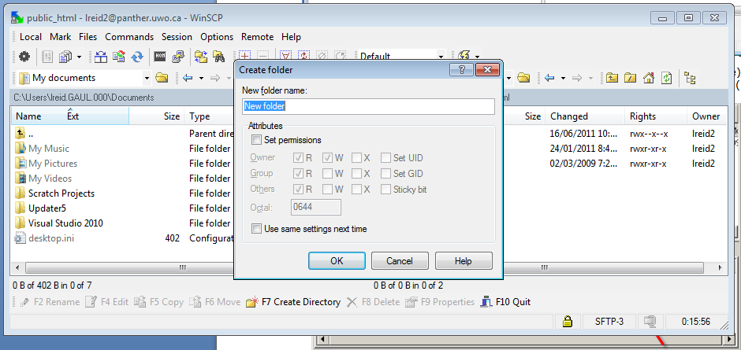
- Make sure you have clicked on the right side panel (the bar will be a darker blue), then click on the F7 Create Directory button (or just press F7) and create a new directory (folder). You should then see this screen:

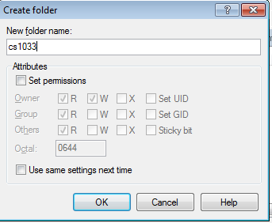
- Type cs2033 for the name of the new folder ALL IN LOWER-CASE AND WITH NO SPACES.

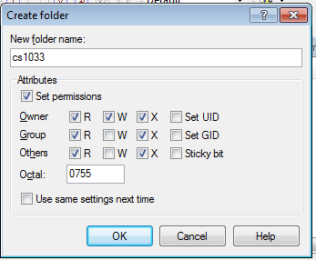
- Click on the Set Permissions box just under attributes and make sure your permissions checkboxes are identical to this →
The Octal box should say 0755
IT IS IMPORTANT TO KNOW THAT ANYTIME YOU CREATE A FOLDER IT MUST HAVE PERMISSIONS OF 0755, otherwise your files inside this folder will not be viewable from the Internet. If you try to view it from the browser you would get an error message saying “You are not authorized to view this page”

- You are now going to upload (transfer) files from your local computer to the Remote side (panther server).
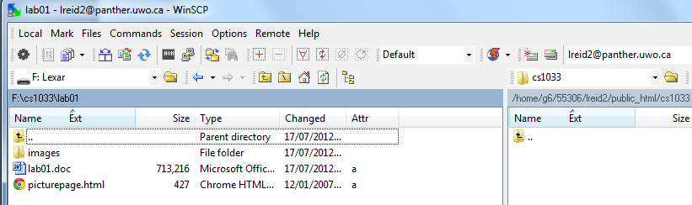
Double click on the cs2033 folder in the right hand panel that you just created so that you are positioned IN the folder. Move your mouse over to the drop down box in the left hand panel near the top of the screen, click on the drop down button and select the memory stick (the F: drive). Then on this left side, find the cs2033 folder you created and click into the lab01 folder that is inside the cs2033 folder. You should then see something like this: (Pay attention to the directory names in the red boxes, instead of lreid2 it will use your username)

When you want to copy a file from your local machine to the server, just click on the file and then press the F5 (copy) button, or drag it from the left side panel over to the right side panel and dropping it there. For example, you could copy the file called lab01.doc by dragging it from the left side panel to the right side panel. You will then see something like this, (just click on the Copy button):
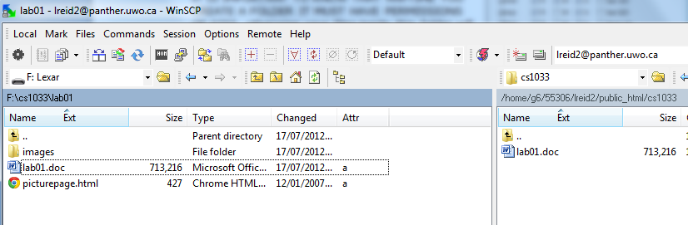
Now we want to see if our file is really on the internet by opening a browser (like IE or Chrome or Firefox) and viewing it.

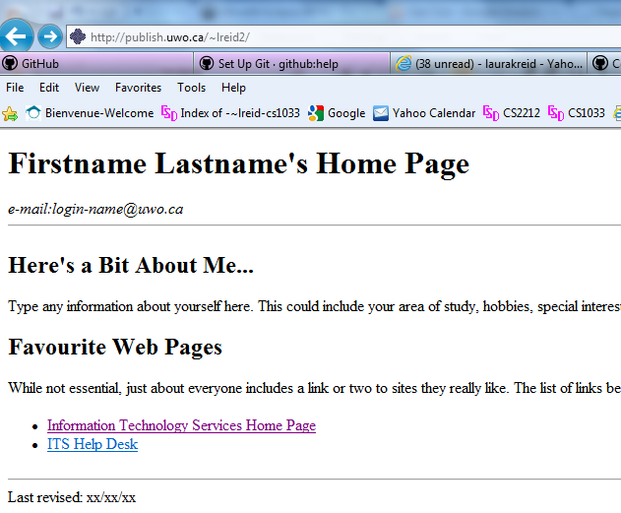
- Open up IE and go to your personal web area that is provided to every Western student. Your personal web area will be at: http://publish.uwo.ca/~youruwouserid You should see something at first like this: (Notice that Western gives every student a default template for a home page).

- Now try to see the page you just uploaded by going into the directory called cs2033. So add /cs2033 to the end of the above web address. Thus, the new web address will be: http://publish.uwo.ca/~youruserid/cs2033/labs/lab01
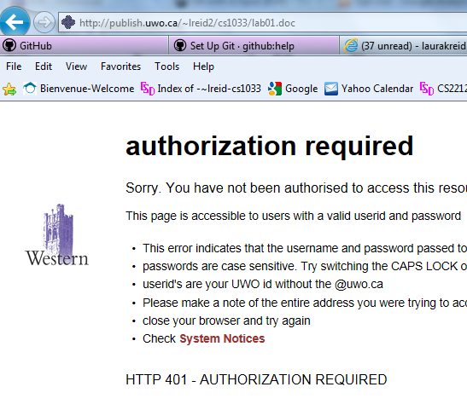

- Then try to click on the lab01.doc file. Unfortunately we still won’t be able to see this file. You should see something like this →
Notice that you get a message “Authorization Required”

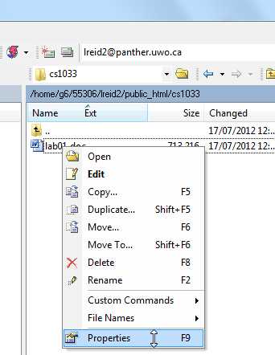
- To fix it so that we can view the files from the browser, we need to ALWAYS set the permission right of files on the remote side in WinSCP. Go back into WinSCP and right click on the folder lab01.doc in the right hand panel. Select Properties.

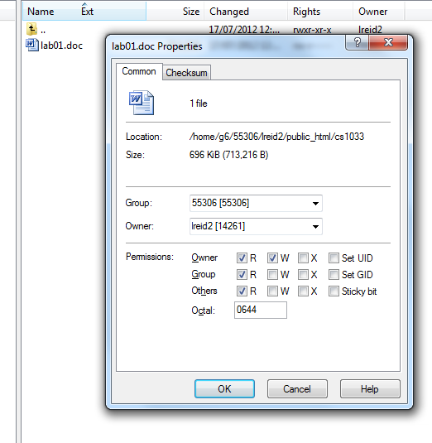
- Make sure that the permissions for the file are checked so that Owner, Group and Others have R (read) access. It should give you Octal value of 0644.

- Now, using IE, go back to your webpage and click on the lab01.doc file again. This time you should be able to open it in IE.
Congratulations! You have posted your first item on the web (from now on, we will post web (html) pages and pictures) but you can really post anything on the internet, even a MS Word .doc document, as we just did ☺
Always remember to set your permissions and remember that the Octal permissions for:
- folders/directory must be 0755
- files must be 0644
Note on Permissions → Whenever you create a file/folder on panther, or copy a file to panther, it will automatically assume that you do NOT want to share that file/folder on the Internet. So anyone who tries to access it on the Internet will get the “You are not authorized to view this page” error. Remember to ALWAYS check the permissions the permissions have been set correctly on your folders (i.e. directories) and files.

Go to your website to preview the page.
http://publish.uwo.ca/~username/cs2033/lab01

Introduction to Affinity Photo

We have just switched from Adobe to Photoshop to Affinity Photo for both CS 1033 and 2033. Most of you learned Photoshop in CS 1033 unless you just took it last semester when we first introduced Affinity Photo.

This portion of the lab is an introduction to Affinity Photo so that you are familiar with this program. The next 2 labs will be advanced Affinity Photo so it is important to learn the basics now so that you are prepared for the coming labs. These exercises are taken directly from the new CS 1033 labs. Not all the 1033 lab exercises are important for you to get caught up, so read the points below for which exercises you are required to complete to get the mark for this lab. You are welcome to complete all the exercises in those labs, but only some are required.

CS1033 Lab #2 (http://www.csd.uwo.ca/~bsarlo/cs1033/labs/lab02/lab02.pdf)
- Read Introduction and Glossary
- Complete Activity 1, 2, 3, and 4
- Skip Activity 5 and 6

CS1033 Lab #3 (http://www.csd.uwo.ca/~bsarlo/cs1033/labs/lab03/lab03.pdf)
- Read Introduction and Glossary
- Complete Activity 1, 2, 3
- Skip Activity 4 and 5

Show the completed work to your TA by the end of Lab #1 to get the mark.

THIS IS A ONE-TIME EXCEPTION THAT YOU MAY COMPLETE THIS LAB BEFORE YOUR LAB SESSION AND SHOW IT TO YOUR TA DURING YOUR LAB #1 SLOT.

REMEMBER TO REMOVE YOUR MEMORY STICK FROM YOUR MACHINE AND PUT IT IN YOUR BACKPACK! (Don’t forget it in the lab)! ☺

