CS1033 Practice/Sample Exam Questions

- Which file format would work best for an image of clouds if you wanted to show your website background partially showing through the clouds?
  - jpg
  - gif
  - png
  - partial transparency is not possible
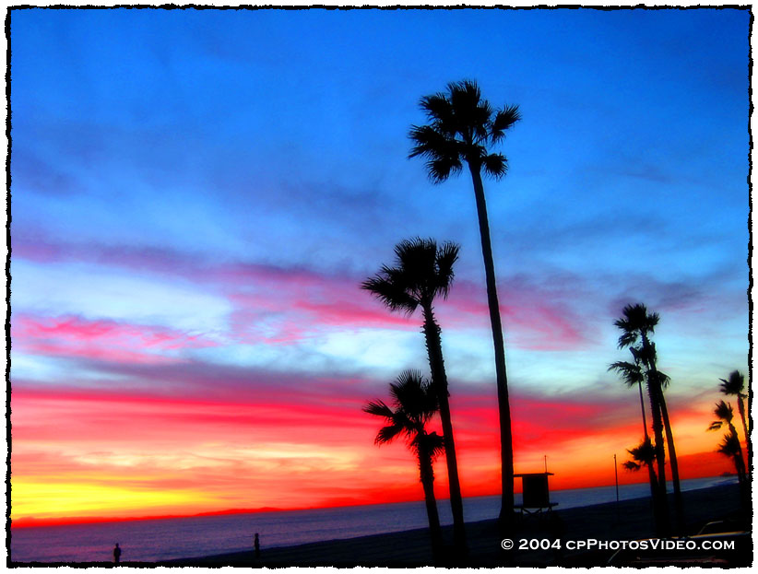
- What colors are the following:
  - #FF0000
  - <255,0,255>
  - <255,255,255>
  - #020202
  - <271, 271, 271>
- What is dithering?
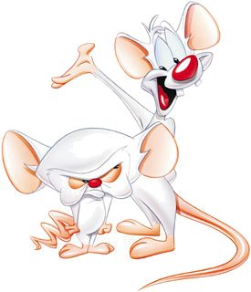
- What format should this picture be stored as:
- What format should this picture be stored as:
- What does the term 1080p mean?
- gif allows for:
  - 2 bit color
  - 8 bit color
  - 24 bit color
  - all of the above
  - a and b only
- jpg compressions realizes that the human eye is better at detecting:
  - differences in color than differences in brightness
  - differences in brightness than differences in color
- If you have a gif image it is better not to keep saving it as a gif repeatedly as it will lose some of its original information and thus degrade in quality
  - true
  - false
- Any font can be displayed on a website, as long as the person building the site has the font installed.
  - True
  - false
- There is always a one to one mapping between an IP address (128.22.3.45) and a domain name (www.csd.uwo.ca)
  - True
  - False
- Which of the following is an invalid IP address
  - 33.44.55.66
  - www.uwo.ca
  - 280.89.300.20
  - a and b
  - b and c
- Which of the follow are valid Top Level Domain Names:
  - www
  - com
  - edu
  - uk
  - ca
- Which of the following is an html tag?
  - <b>
  - (b)
  - b
  - [b]
- Where is the <title> tag displayed?
- If you were viewing a web page and then clicked View Source, you would see:
  - text consisting of content and html tags
  - the actual images, links and content
  - links and the actual images only
- What are the four fundamentals discussed in class of any good design
- In an audio wave plot, the horizontal distance between waves indicates which characteristic of the sound?
  - volume
  - pitch
  - track length
  - a) and b)
- A tween is
  - The frame that contains the last movement in your animation
  - The computer generated frames between two positions in an animation
  - The location where the music goes in an animation
- Kerning is
  - The space between two lines of text
  - The space between two characters
  - The spacing across an entire row of text
- The lowest resolution you should have when creating an image to be printed is
  - 72 ppi
  - 96 ppi
  - 200 ppi
  - 300 ppi
  - 1200 ppi
- Cinemagraphs are images that are transparent.
  - True
  - False
- What occurs when you type in a search term on Google?
  - A web crawler/spider crawls the Internet
  - Google builds a database of websites pertaining to your search
  - Google looks in their index for the search term and then their ever-changing database to get URLs that contain the search term
- Tim Berners Lee was instrumental in creating the internet in 1969.
  - True
  - False
- What is the key idea behind the Page Rank algorithm of Google?
- How many bits are required for storing 16 possible colours?
- JPG compression is called lossless because pixel colours are removed to reduce filesize.
  - True
  - False
- What is the name of the software that transfers files to a webserver
- What is the name of the web server at Western
- Match the following words to the definitions
a. Lossy compression | 1. file format for images that supports variable transparency
b. PNG | 2. file format for images that can display animation
c. .jpg | 3. the amount of information stored for each image
d. colour resolution | 4. measures the number of bits of stored info per pixel (or how many different tones every pixel can have)
e. gif | 5. A way of reducing filesize by discarding pixel colours and setting them to nearby similar colours
f. image resolution | 6. file format for images that is best used for continuous tone images such as photographs

- Look at the following images:
Original   | Resized to enlarge  
Was the original image a vector graphic or a bit mapped graphic?
              - Vector
              - Bitmapped (Raster)
- Calculate the decimal number value of the binary number 1010:
  - 2
  - 10
  - 1000
  - 1001
  - 1020
- Which of the following are composed of tiny dots, each corresponding to one pixel on the computer’s display?
  - codecs
  - vector graphics
  - bit-mapped graphics
  - arrays
  - points
- What are the characteristics that define a cel-based animation. Within a scene:
  - Background changes from one scene to another, and object changes from one frame to another.
  - Background changes from one scene to another, and object remains fixed.
  - Background remains fixed, and object changes from one frame to another.
  - Background remains fixed, and object remains fixed.
- When using a table in KompoZer, to adjust the spacing around each cell so that text does not touch the grid cells, one would assign a value to the “cell spacing” or “cell padding”.
  - Spacing
  - Padding
- Match the following words to the definitions
a. animation | 1. the illusion of a moving or changing graphic image
b. ease | 2 when the illusion of motion fails and the animation appears as a sequence of still images being displayed rapidly
c. flicker | 3. beginning the motion slowly and then accelerating its rate
d. morphing | 4. changing one object to another
e. tweening | 5. a clear sheet on which images are drawn, and placed over a stationary background
f. cel | 6. drawing the frames in between the key frame

- Match the following term to the best definition
a. sample size | 1. a technique, done by a codec that reduces the size of a file.
b. compression | 2 the number of bits used to represent a sample of the wave
c. frequency | 3. distance between the peak and valley of a wave form and indicates the volume
d. amplitude | 4. a continuous stream of sound wave
e. analog sound | 5. advanced process that allows the sound to be played on the computer before the entire file is transferred to the users computer
f. streaming | 6. number of peaks that occur in one second measured by the distance between the peaks (closer peaks are higher pitch sounds)
g. channel | 7. The left and right “tracks” that separate mono sound into stereo sound

- Match the following term to the best definition
a. bit rate | 1. the ratio of width to height in a frame of video
b. codec | 2. the size of a video (in bits, not bytes) divided by the number of seconds it is in length
c. aspect ratio | 3. a compression/decompression algorithm used to compress data
d. bit depth | 4. video playback that changes its quality based on the available band width
e. playback frame rate | 5. the speed at which the individual frames are displayed
f. adaptive streaming | 6. the ratio of each video component layers per 4x4 grid of pixels (i.e. 4:4:4)
g. colour sampling (YUV) | 7. the number of bits used to describe the color of a single pixel

- The term multimedia is best described as:
  - The use of electronic signals to communicate via a computer
  - The integration of text, graphics, animation, sound, and video in an application for the purpose of communicating
  - The creation of images via a tool such as Photoshop
  - The integration of sound and video via a tool such as Windows Movie Maker
  - c) and d) only

- A vector-based image has the following characteristics:
  - Image is represented with lines and arcs that have a mathematical relationship
  - Quality is retained as image is increased in size
  - As image is increased, edges of image become jagged
  - All of the above
  - Both a) and b).

- In animation, a snapshot of what’s happening at a particular moment is known as a:
  - movement
  - frame
  - sample
  - model
- The term FTP stands for:
  - Film Transfer Process
  - File Transfer Protocol
  - File Transfer Process
  - File Tracking Process
- What does the CreativeCommon icon  (NC) mean when found on digital content?
  - The graphic may be used for non-commercial works
  - The graphic may be used but must be accompanied by author attribution
  - The graphic may be used exactly as is, not altered in any way
  - The graphic may be used as long as its CC license is not altered
- Streaming is the process of taking a large audio or video file and transmitting small, continuous amounts of that file over a network in a steady and continuous manner. The streamed video/audio is never stored on the hard drive but a portion of it is in the memory of the computer where the video is being displayed.
  - True
  - False
- When using graphics software, a native file format means that the image properties/attributes are retained and can easily be edited.
  - True
  - False
- A web host is needed as part of getting a website operational. Which of the following should not be a consideration when selecting a web hosting service? The web host’s
  - Web site building software
  - Disk storage for storing web pages
  - Available bandwidth
  - Up time
  - Technical support
- The main language for making websites is called:
  - ISP
  - FTP
  - HTTP
  - HTML
- The term 4K refers to:
  - Ultra high resolution in TVs
  - 1080 scan lines for video
  - Retina display
  - Plasma TV
  - All of the above
- Animation is used in websites in order to:
  - Illustrate movement over time
  - Assist with visualizing three dimensional objects
  - Create interest on a website
  - All of the above
  - a) and b) only
- What is the html code required to insert video into your website:
  - <src>
  - <controls>
  - <video>
  - <codec>
- Hexadecimal representation of colours (i.e. #A74301) offers many more colour possibilities than RGB representation (i.e. (15,200,55))
  - True
  - False – RGB offers more than hexadecimal
  - False – They offer the exact same amount
- Assuming you have an image that is 800 pixels by 600 pixels and has a dpi of 200, how big will it be if you print it?
- Assuming you have 3 images, all are 800pixels by 600 pixels, image A has a dpi of 200, image B has a dpi of 100, image C has a dpi of 10, which image will print out the largest?
- Which image in the question above will have the largest filesize in bytes (assuming there is no compression)
- If the images mentioned above are 24 bit colour, how big will the file size (in kilobytes) be of image A? (just show the calculation) ___________________
- What type of sound format doesn’t represent voice very well?
- MP3 does lossless compression on sound: TRUE or FALSE
- Youtube is moving away from displaying its videos as .flv files and towards what file format? ___________________
- If a piece of paper is 5 inches by 5 inches and has a ½ border ALL around it, and you are going to print text at 18 point on it, with 0 leading, how many lines will you be able to fit on the paper?
- Who founded google?
- What year was the World Wide Web founded and by whom?
- A web crawler creates an index of keywords (true or false)
- What should the first page of a site be called?
- What are some things you can do to make animation more realistic (we gave you 4-5 things)
- It is possible to create an animation that loops in Photoshop (T or F)
- Copying analog video from one tape to another loses quality (T or F)
- JPG images can ONLY display 256 possible colours (T or F)
- It is impossible to store a number bigger than 1024 as a binary number (T or F)

